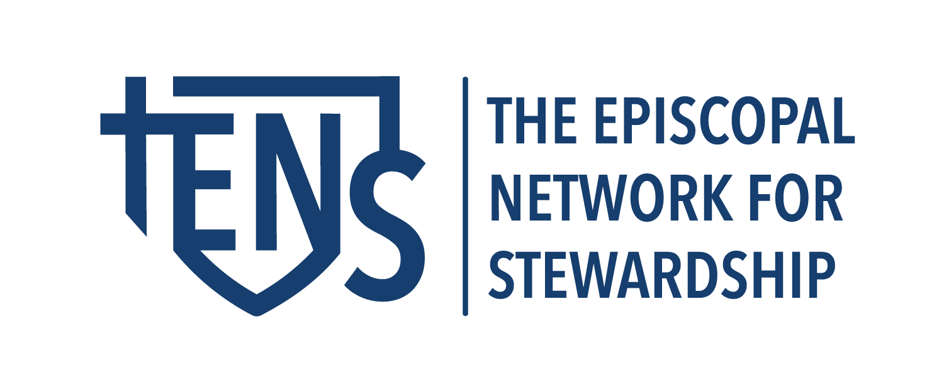

📋 Stewardship Campaign FAQ – Key Questions

🎯 Purpose & Theology of Giving
What is stewardship, and why is it important in our church?
Stewardship is our grateful response to God’s generosity. In Creation, God made everything that is, everything that will be, and gave it all to us to harness and steward. Our responsibility is to carry on the Love that inspired this original gift by using our gifts to make the world a better place, to seek and serve God in our neighbor, to work for justice and peace. All of our gifts – time, talent, and treasure – work together to enact and enable the Mission of the Church
Why does the church ask for a pledge instead of just passing the plate?
Our church uses pledges, or anticipated income for the coming year, to generate a budget from which we can create a spending plan for our ministries. Some members can anticipate their income for the coming year, and we ask them to make a pledge or a promise based on that. Whether a member chooses to make a gift through pledge or by other means, every gift matters.
We also ask members to indicate interest or commitment to our ministries with their time and talent. It takes many people to create liturgy and programs that feed our souls and provide support to our neighbors. Many members include these commitments as a part of their pledge.
Is giving a spiritual practice? How is it connected to my faith?
Giving is a deeply scriptural and spiritual practice, rooted in our most ancient traditions. Scripture reminds us to give freely (Matthew 10:8); and to do good and share with others (Hebrews 13:16); and that even the smallest gifts matter (Luke 21:1-4). Our traditions remind us that giving alms, giving as we have received, is a part of our commitment to our community of faith and our neighbors.
As with any spiritual practice, it needs - practice! The more we imagine ways to share what we have learned, acquired, received, and understood with our church and the world, the more deeply connected to the original gift of Creation we become.

💰 Pledging & Giving Mechanics
What is a pledge?
Your pledge is an act of love and hope for your congregation. It’s a vote of support for the ministry that you offer to your fellow members and your neighbors. It is a way to support the long-term goals and physical needs of your church while supporting your members in the pastoral needs that they have now. Your pledge, or promise, is a commitment to give time, talent, and treasure to your congregation in the year to come.
How do I make a pledge? (paper form, online, app, etc.)
You should include specific instructions for your members to make their commitments and how to handle them. This includes where to send them, any dates or timelines to consider (ingathering or other ending celebrations), and what methods they can use. Consider having email (pdf), online, and paper methods. Use this section of the FAQ to list the ways that you have identified in your church.
Can I change my pledge if my circumstances change?
Your pledge is not a debt, and it is not a contract. It is a commitment between your household and the household of God, made with mutual love and respect. If your circumstances change at any time, you may change your commitment. A simple email to the treasurer or parish administrator is all that is needed.
Our lives are intertwined, and your membership in our community runs much more deeply than your ability to make financial gifts. If there are things we can do for you to support you through the circumstances that you encounter, please contact our clergy or pastoral care team.
What happens if I can’t fulfill my pledge?
Your pledge is not a debt, and it is not a contract. It is a commitment between your household and the household of God, made with mutual love and respect. If your circumstances change at any time, you may change your commitment. A simple email to the treasurer or parish administrator is all that is needed. It is helpful for us to know sooner rather than later so that we can make adjustments to our budget.
Do I have to pay my pledge all at once?
Some members do pay their pledge all at once, some fulfill it weekly, or at other convenient intervals. How you fulfill your financial pledge is up to you and your household budgeting. If the pledge card asks you to select a model (weekly, monthly, annually, etc), choose the one that fits best your needs. It helps the treasurer understand the cashflow.
How can I give? (check, cash, online, stock gifts, donor-advised funds, IRA distributions, etc.)
It is a good practice to diversify the ways that members can make their gifts. In addition to cash and checks, consider the other options your members might want to employ. Offer as many online and offline ways as you can. Use this section of the FAQ to include the giving channels that your congregation uses.
Can I set up automatic recurring gifts?
Online or mobile giving and bank transfers often offer the option of making a gift recurring through a simple menu choice or toggle. Members can specify the frequency of their giving.

📊 Church Budget & Use of Funds
How is the church’s budget created?

This section should include some concise answers about your budgeting process. Consider describing how the Vestry, Clergy, and Finance Committee work together. What is the role of Stewardship in your budgeting process?

Where does my money go? What does it support? What percentage of the budget supports outreach, worship, staff, diocesan giving, facilities, etc.?
Consider pie charts of income and expenses. How does your congregation receive its money, and how is it spent? See our article on Creating a Congregational Narrative Budget for some tips on how to describe your budget.

🔍 Giving Benchmarks & Context
How much should I give? Is there a guideline?
This is a deeply personal question with an answer that is unique to you and your household. We have included some data on the ranges of giving in our congregation as you discern your gift. See our document “Steps for Household Giving” for a useful tool to show where giving patterns are in your congreation
What is a “proportional gift” or a “percentage of income” pledge?
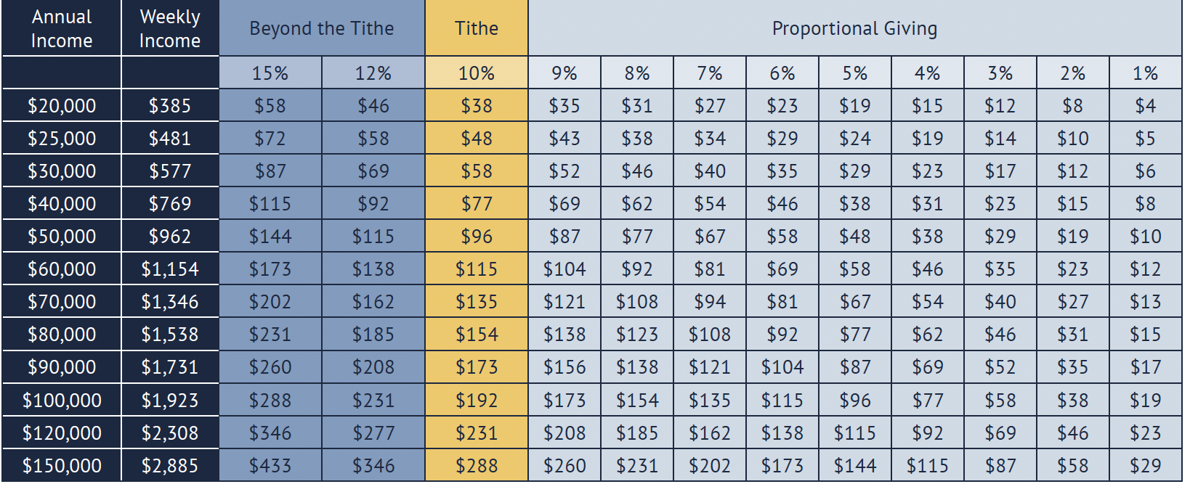
Can I give anonymously? Is my giving confidential? Who sees my pledge or giving record?
We do not publish a list of donors or their amounts, so in that sense, all gifts are anonymous. Giving is confidential, save for the finance officer who records your gift, deposits it, accounts for it, and issues statements. You can always request additional levels of confidentiality if you have particular concerns.

🤝 Community & Participation
I’m new to the church. Should I pledge?
One of the ways that Episcopalians participate in church is by making a gift of time, talent, and treasure. As you consider becoming an active member of this community, how would you like to share your gifts? There are so many ways to serve in the liturgy, in our programs, volunteering for groups and work around the church, and making regular financial gifts. All of our members give something of themselves, and we ask that you discern what your offerings might be.
What if I don’t have much to give?
We read in Mark 12: 41-44 about the Widow’s Mite, reminding us that every gift matters when it is made from the heart: “Jesus sat down opposite the treasury and watched the crowd putting money into the treasury. Many rich people put in large sums. A poor widow came and put in two small copper coins, which are worth a penny. Then he called his disciples and said to them, “Truly I tell you, this poor widow has put in more than all those who are contributing to the treasury. For all of them have contributed out of their abundance, but she out of her poverty has put in everything she had, all she had to live on.”
Can I participate in the church without pledging?
Wherever you are on your journey of faith you are welcome here. Our community is a welcoming, vibrant one where every member contributes their gifts to support our work. However you choose to show your generosity to this congregation will be appreciated.
What if I already give my time—why give money too?
Our whole stewardship, the way we give thanks for all the ways in which we have been blessed by God, is comprised of our time, talent, and treasure. All three go into creating a sustainable community focused on its mission to support the faithful and to meet our neighbors where they are with love and joy.
How does my pledge support the church’s mission in the community and beyond?
In our community, every dollar goes to mission. Our outreach, our operations, our community and pastoral care are all member-supported ministries. Our budget and our narrative budget describe how we share our resources with our neighbors.

🧾 Tax & Legal Questions
Is my gift tax-deductible?
All gifts to the operating fund are tax-deductible to the extent allowable by law. We are a 501(c)(3) organization with EIN {it is good practice to provide your tax-id or Federal EIN number}
Will I receive a giving statement?
It is our practice to send out regular giving statements. They are issued at the following dates. {It is good practice to send at least a mid-year statement. Quarterly statements are even better.}
Can I give in honor or memory of someone?
Your gift to church represents your household. While you may designate special offerings, flowers, or other honorary gifts throughout the year, your pledge is considered a gift to God from you and your family.
🧡 Bonus Additions
- Include a quote from scripture that grounds giving theologically.
- Share a pie chart or infographic of budget allocation.
- Offer a contact person for confidential conversations (e.g., stewardship chair or rector).

